Perf Review

## San Jose State University

## CMPE-272 :Enterprise Software Platforms

Professor: Andrew Bond

ISA: Akanksha Jaiswal

Group Name:Techie Tribe

Team Members: [Bhavya Tetali,](https://www.linkedin.com/in/bhavyatetali3/) [Pranjali Kotgire](https://www.linkedin.com/in/pranjali-kotgire/),Sneha Patil, [Supriya Meduri](https://www.linkedin.com/in/supriya-meduri-a846377a/)

**Project Introduction:**

* Perf Review is an enterprise application that allows two role based access.
* **Managers** and **Employees** to securely login through Single Sign On.
* The manager can provide the employee with ratings, view the employee ratings already provided in the chart.
* Also the employees can view the ratings provided by the manager.

**Enhancement made to the base project:**

* As an extension to this project, we included chatbot cloud service for making the performance evaluation task much more manageable and quick for managers.
* The project is built using a serverless approach.
* The deployment process is automated using various cloud services like AWS Cloud Formation, S3, Lex and CodeBuild

**Tech Stack**

* Node.js
* Express
* HTML, Javascript, Bootstrap
* RDS - For accessing employee data in the default project
* Okta Single sign on using OIDC
* Jenkins - For CI/CD

**Cloud Services Used**: We primarily used Amazon Web Services for our cloud needs.

* Route53 - This is the Domain Name Server which is used to resolve the IP address of the application domain.
* Lambda - This service is used for writing the serverless backend functionality for lex UI.
* RDS - Launch a MySQL instance and connect to the workbench where employee data is managed. Created read replicas to have high availability and failover support
* Lex - This service is used to enhance user experience and user interaction by using a chatbot that helps managers to provide feedback/ratings to employees.
* Cloud Formation - This service provides a template to build and deploy the AWS Lex web interface automatically. The web application is configured and deployed directly to the S3 bucket utilizing Code Build. The cloud Formation stack links to an iframe embedded in our application.
* Simple Storage Service(S3) - This service is used to store the web Ui of Lex chatbot. Enabled cross region replication for disaster recovery.
* Cloud Watch - This will be used to create monitoring for RDS,lambda etc when the free storage space limit threshold is reached it sends the notification via SNS.
* Simple Notification Service(SNS) - It is the Notification Service for AWS resources which sends email and text messages on the particular top gets the configured events.

## **Git Repo**: <https://github.com/kotgirep/employee-perf-review/tree/master>

## **Project Demo Video URL**: https://www.youtube.com/watch?v=DZafk4r9mHQ

**Website URL**: <https://www.perfportaltechietribe.ml/>

**Test Account Credentials** :

1. Manager : pranjalikotgire57@gmail.com / Apple@123
2. Employee:
   1. sneha.magdum11@gmail.com / Apple@123, employee id - 10077
   2. pranjali.kotgire@[sjsu.edu/ Apple@123](http://sjsu.edu/Apple@123), employee id - 10086
   3. supriyameduri@gmail.com / Apple@123
   4. bhavyatetali3@gmail.com / Apple@123

**Architecture Diagram**

**DB Employees :**

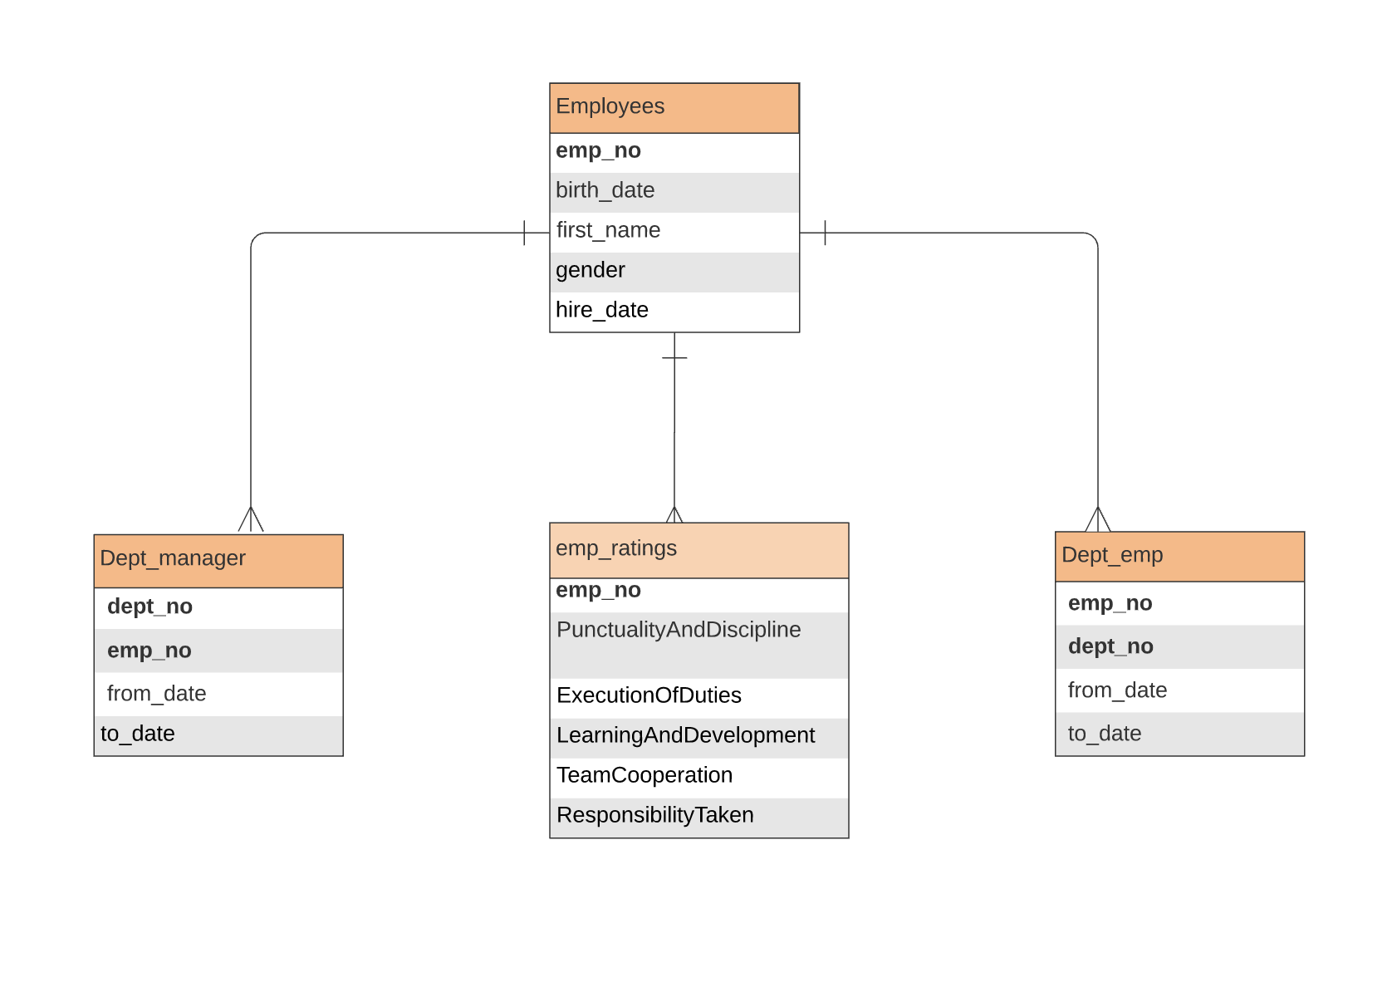

**Database Design:**

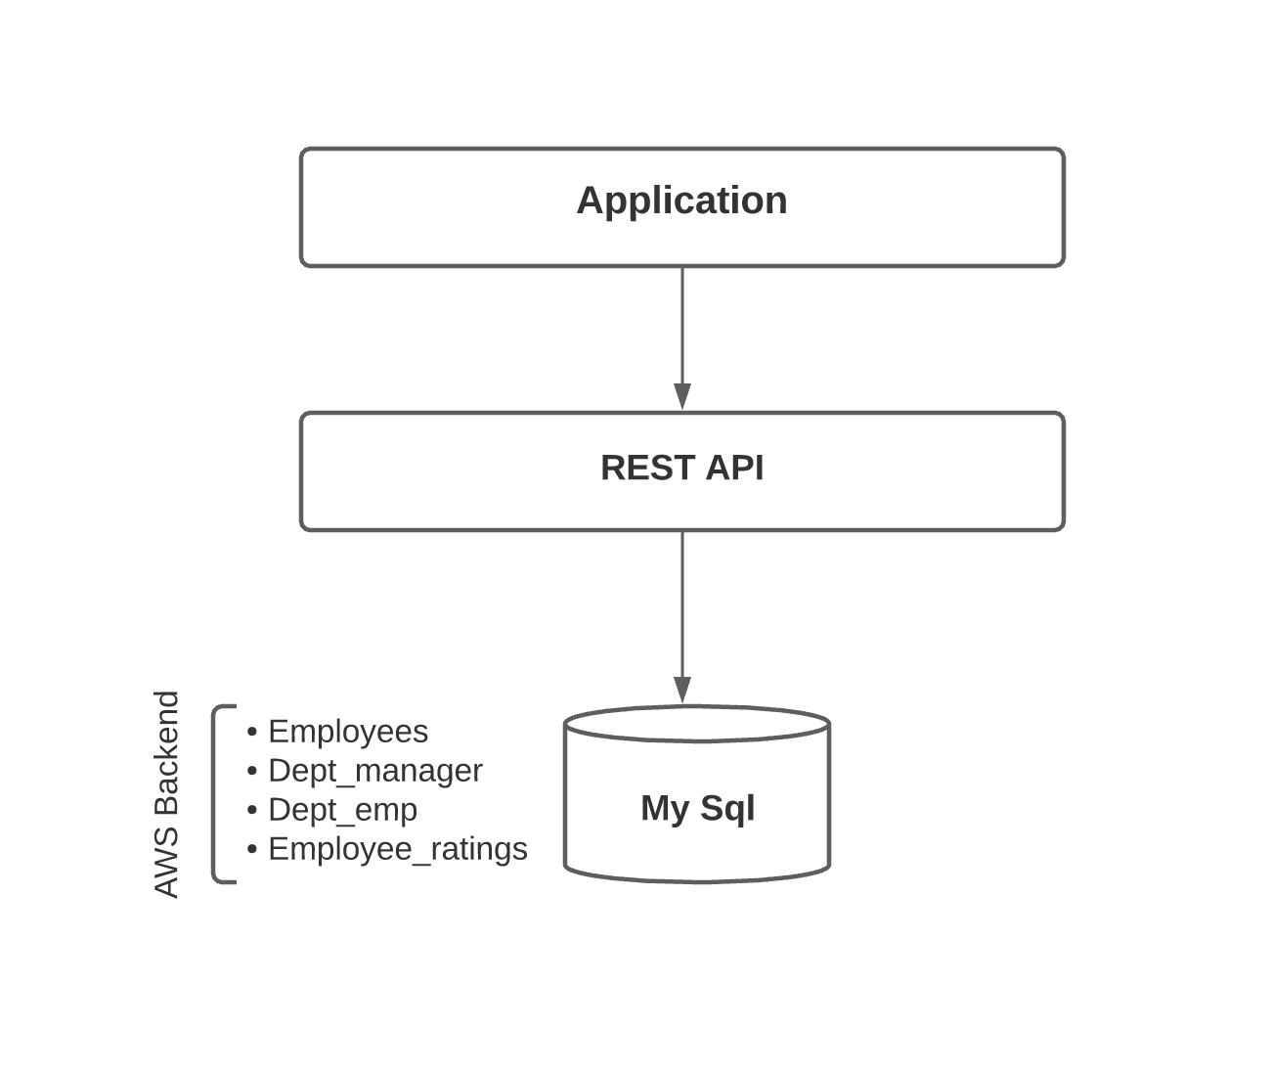

**Activity Diagram:**

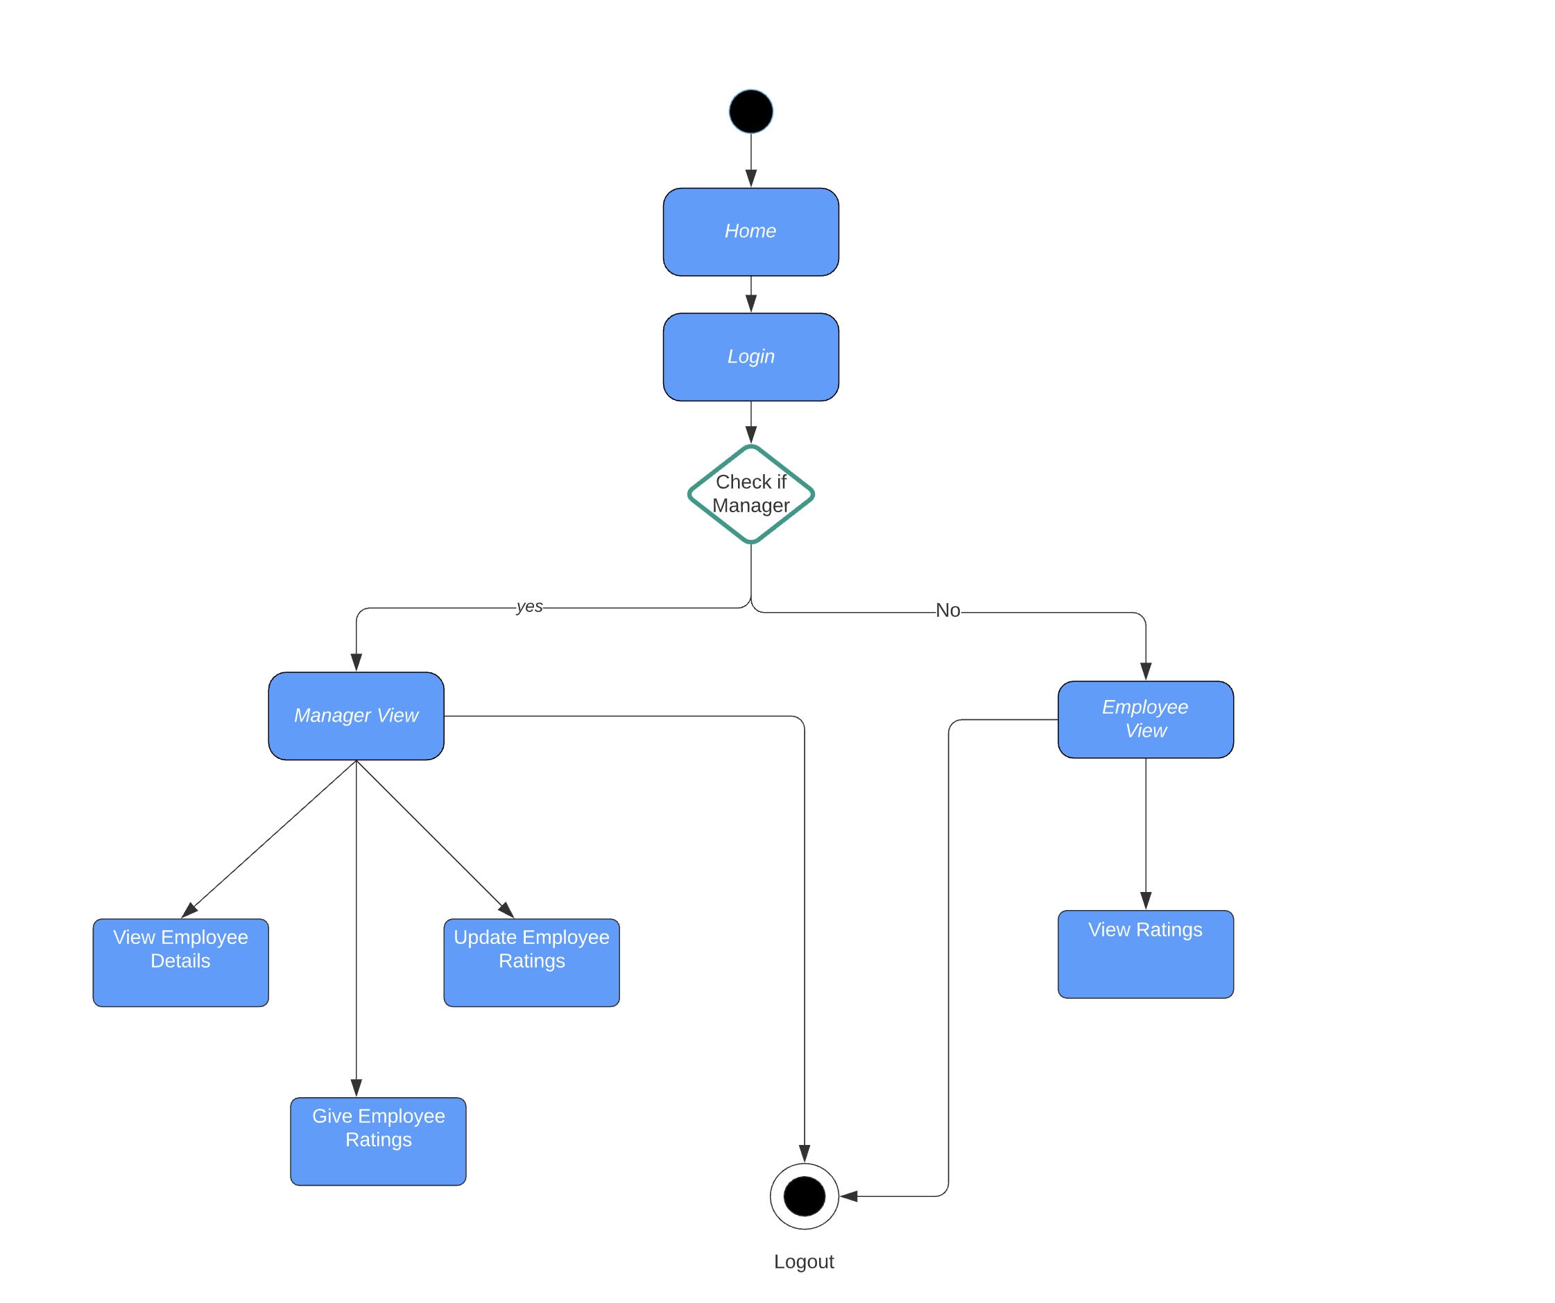

**Single Sign On Using Okta:**

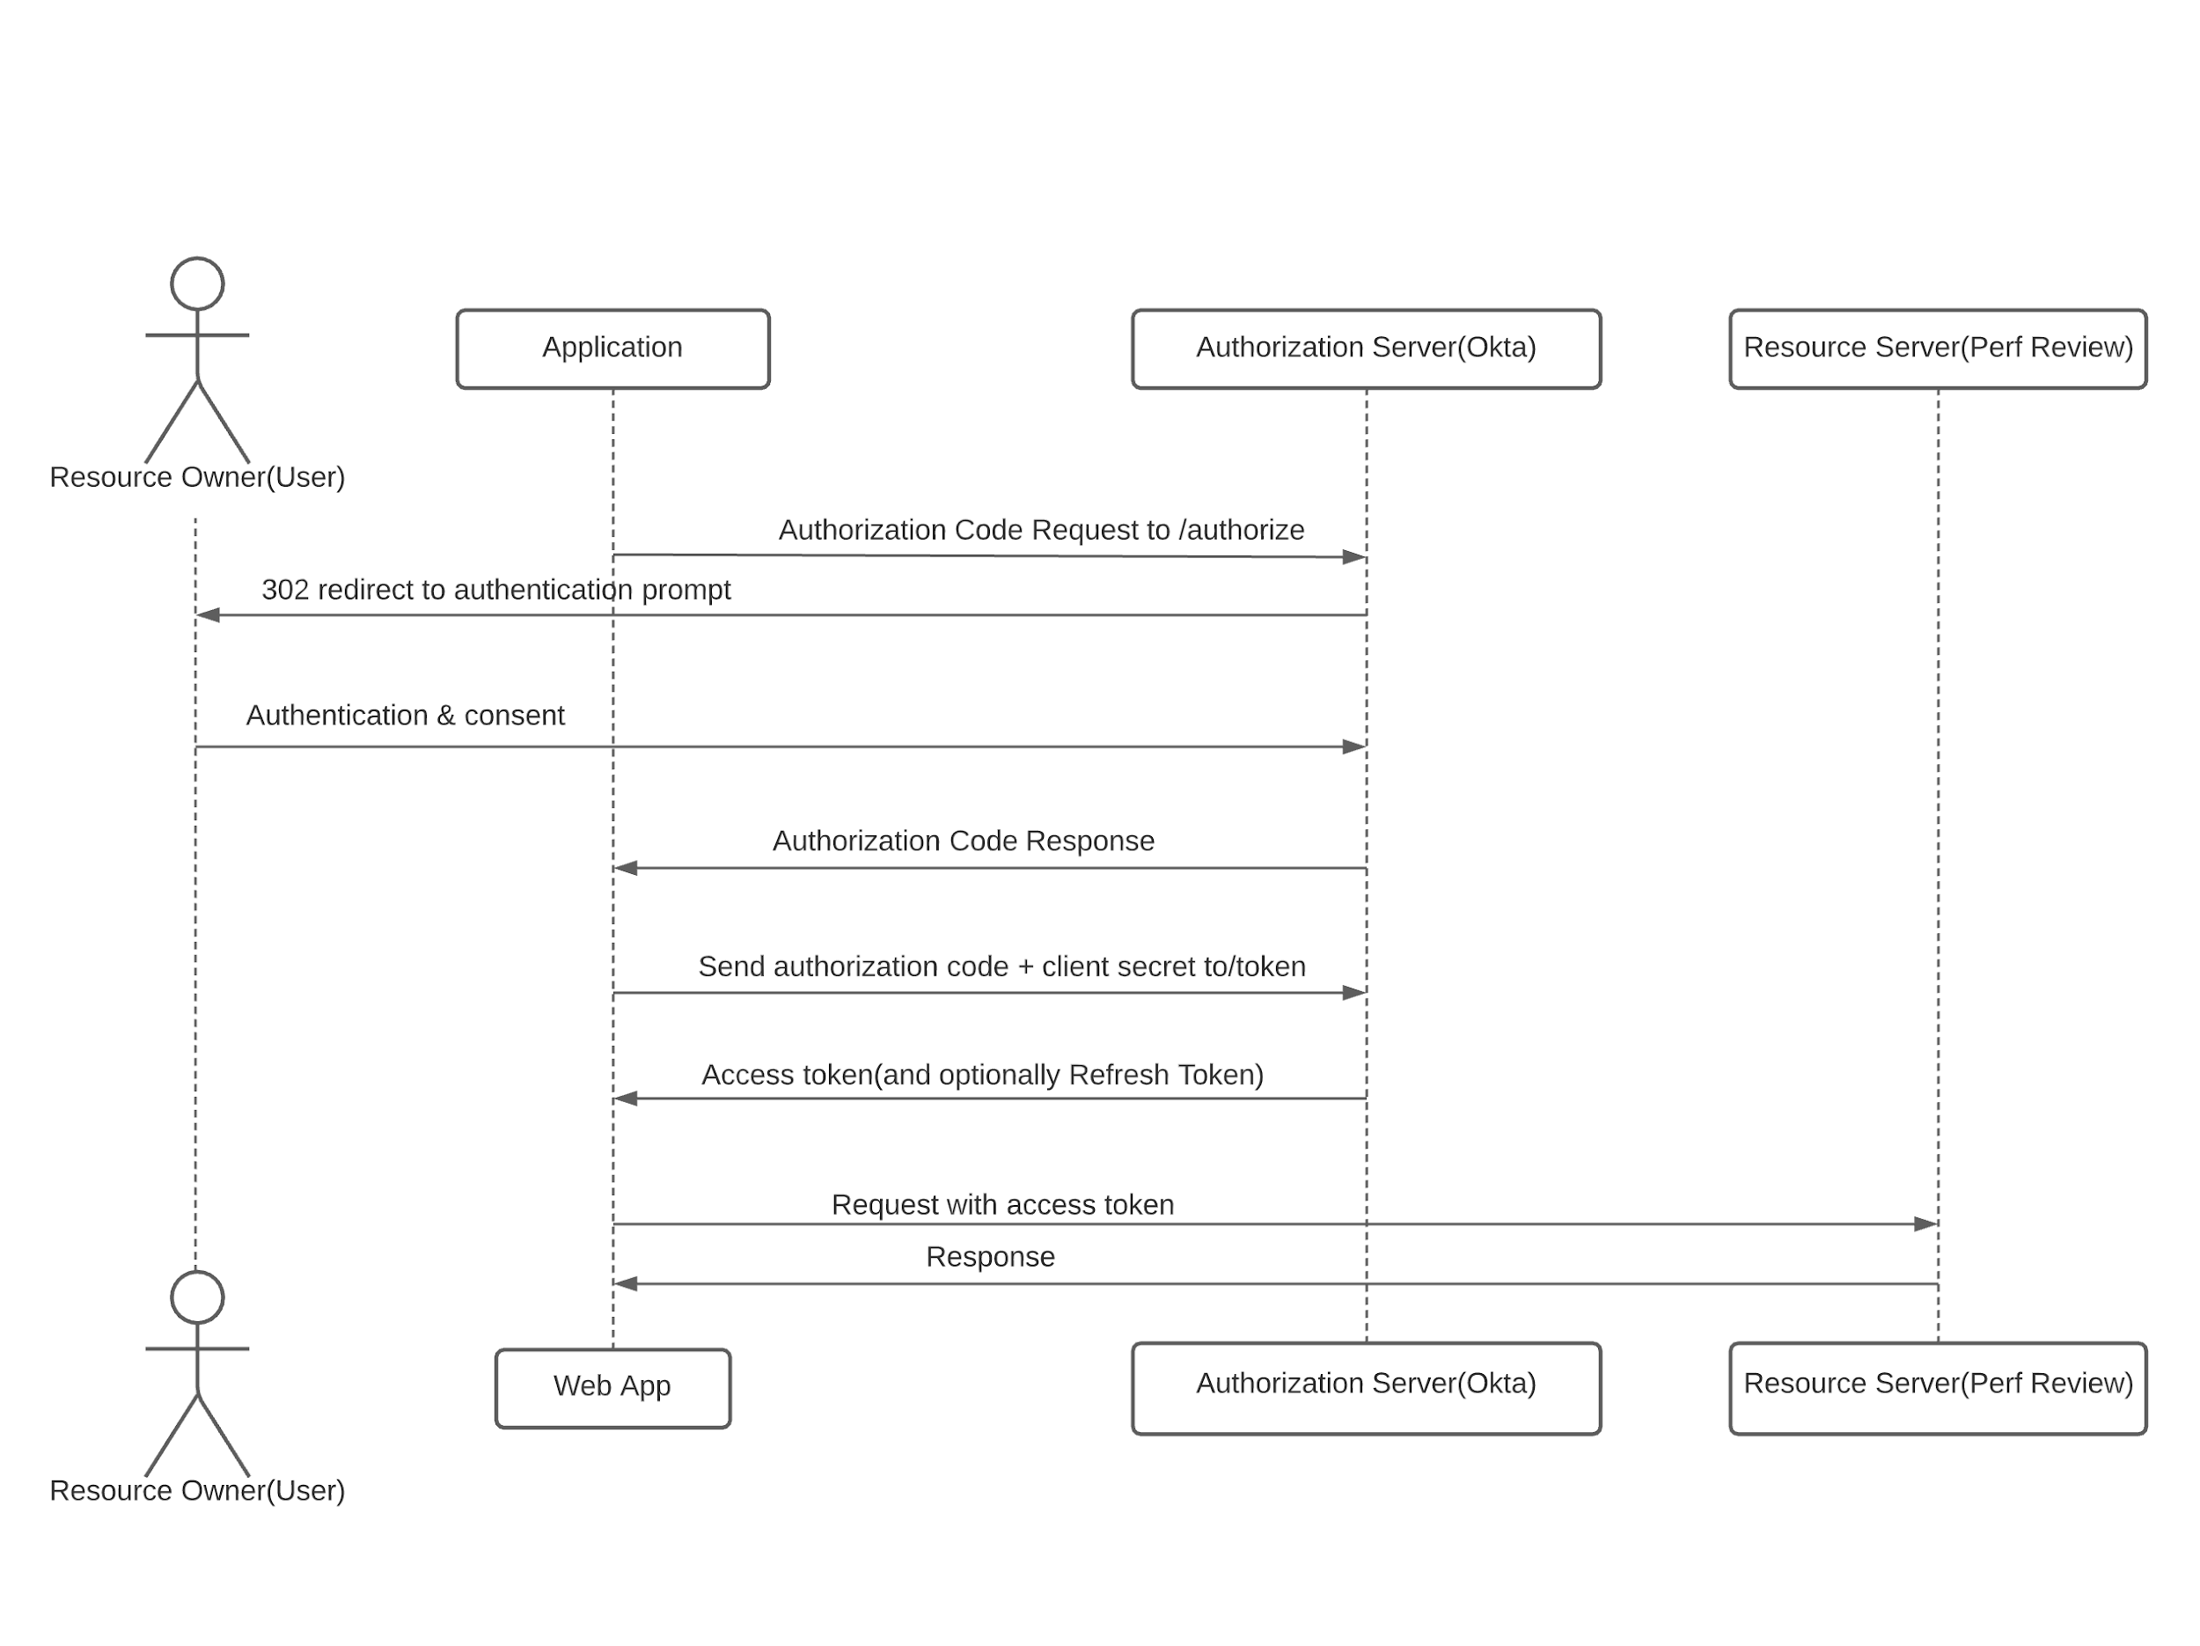

**AWS Architecture Diagram:**

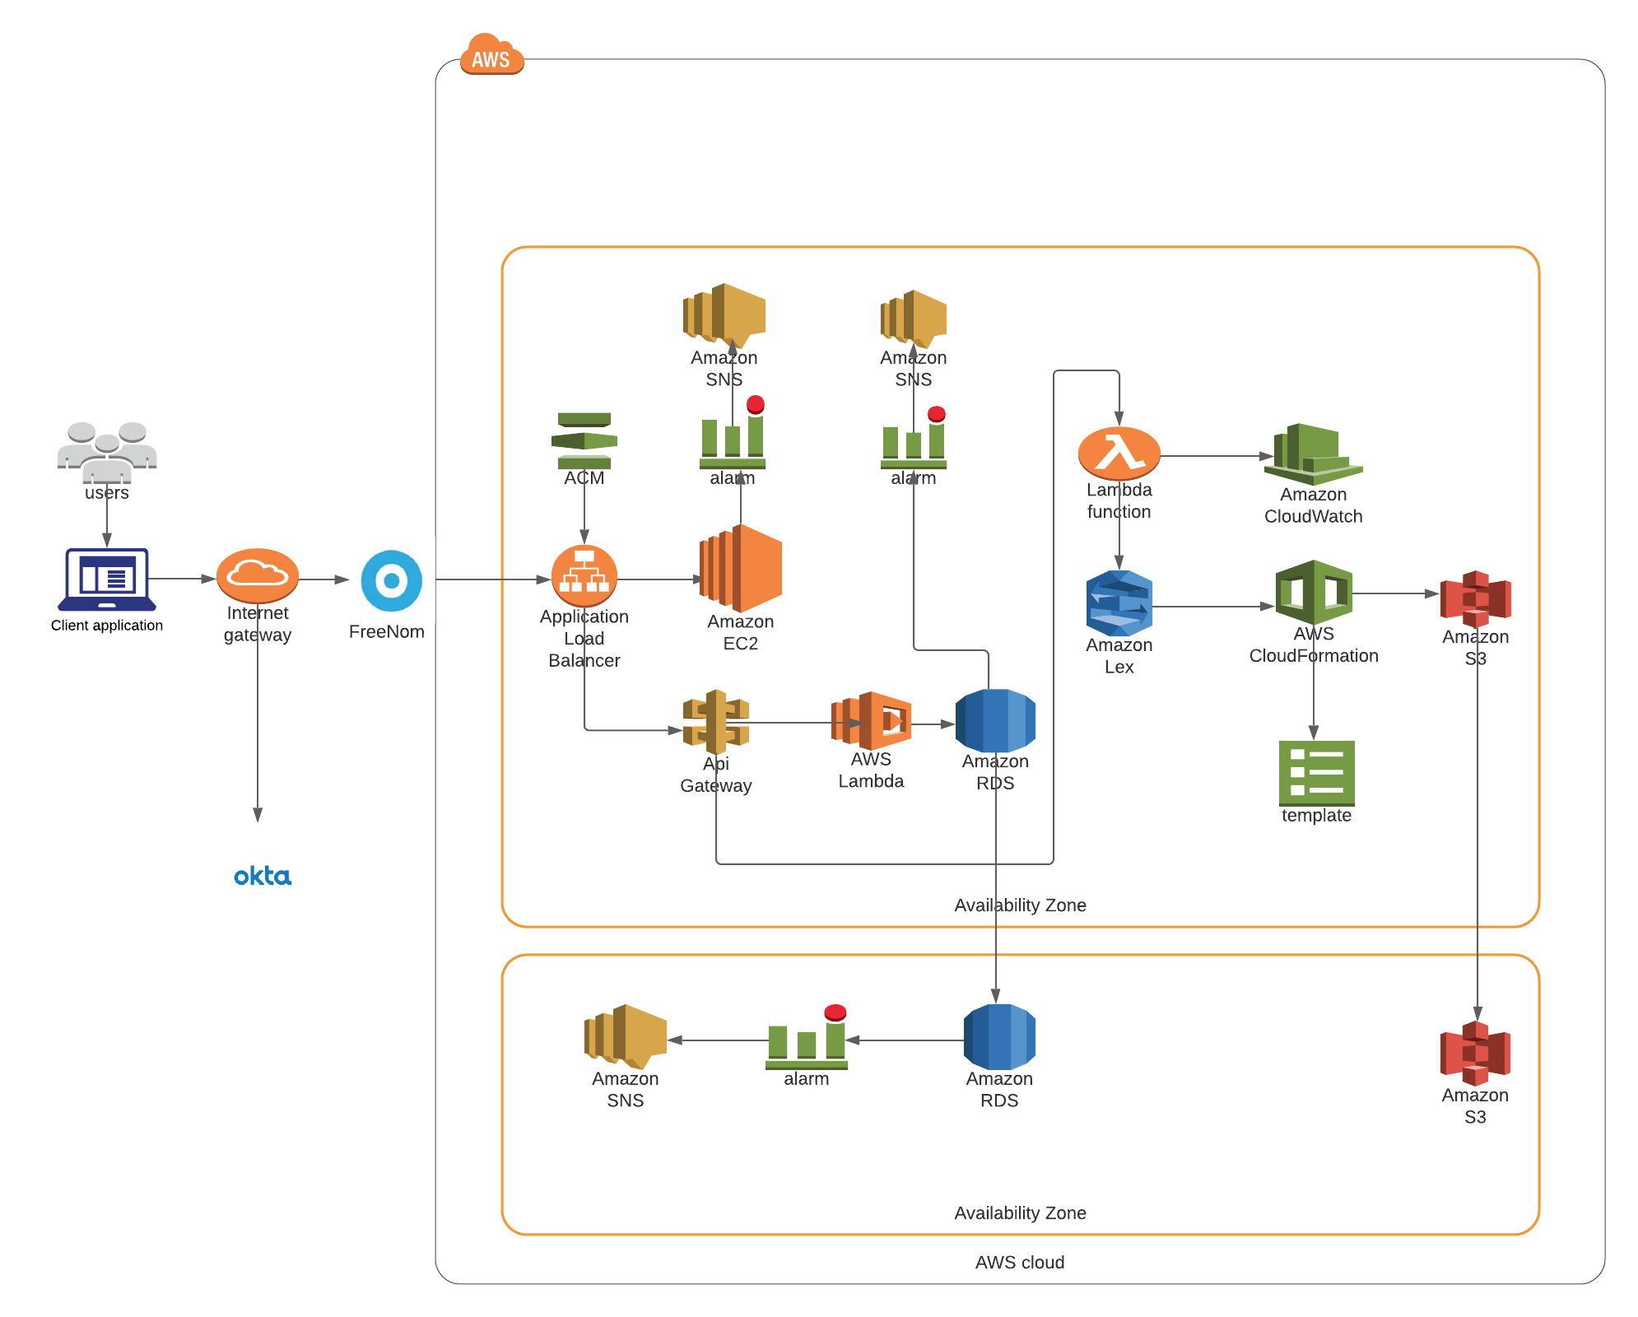

**CI/CD Screenshots:**

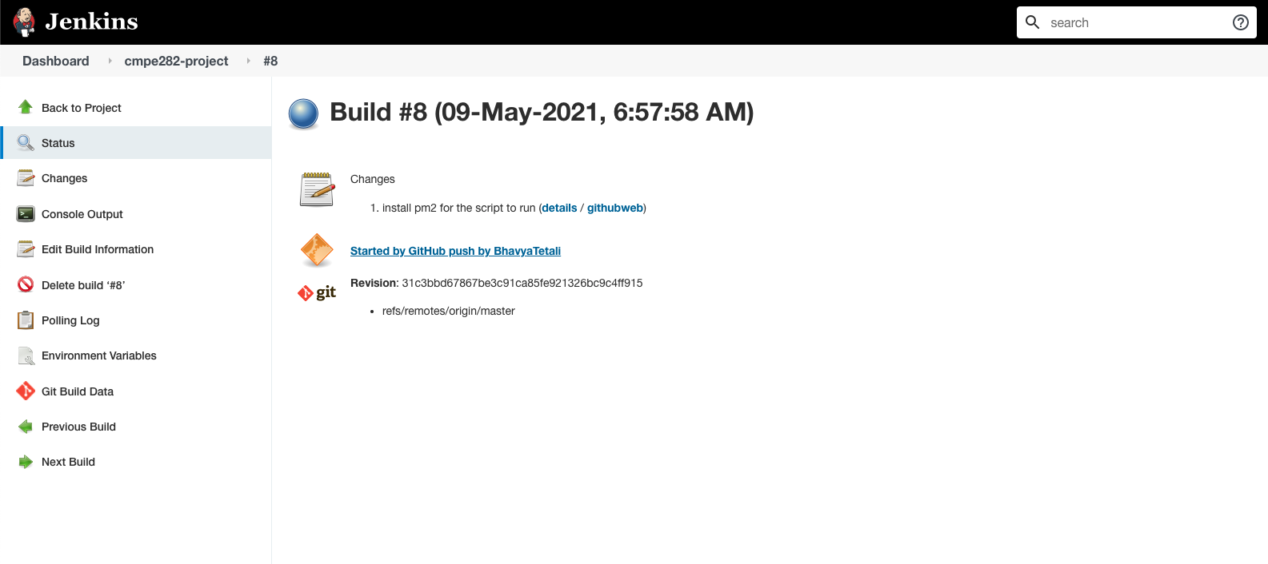

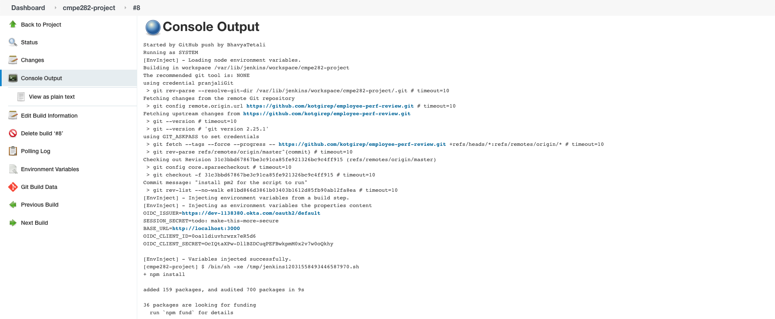

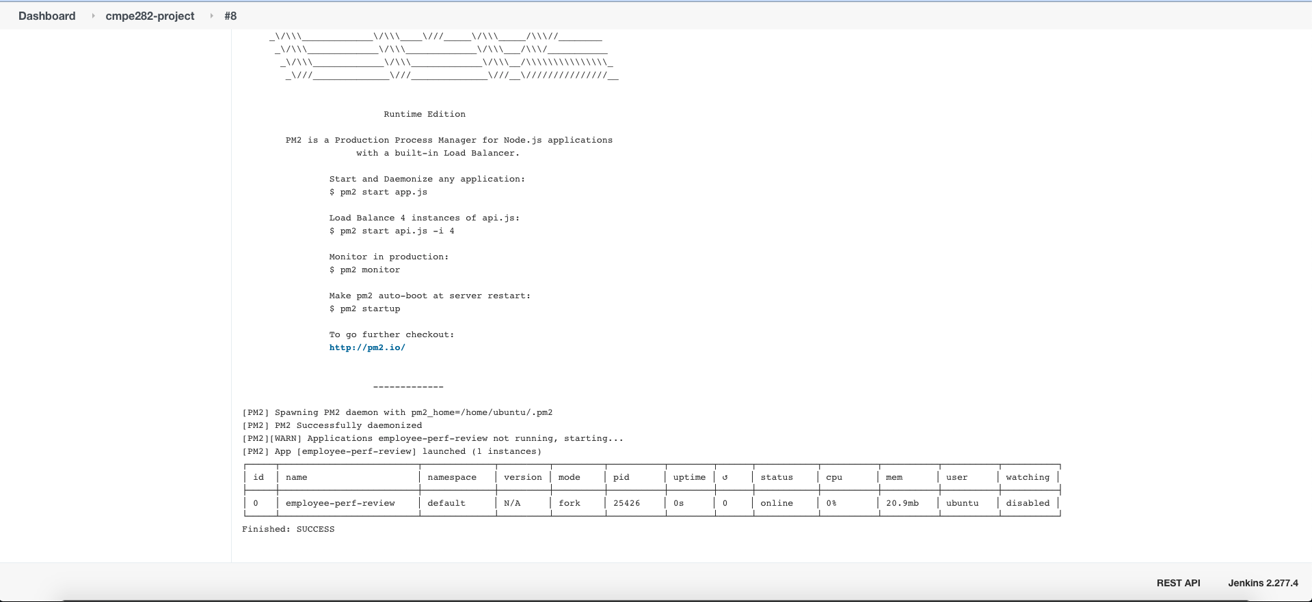

**Sample Demo Screenshots:**

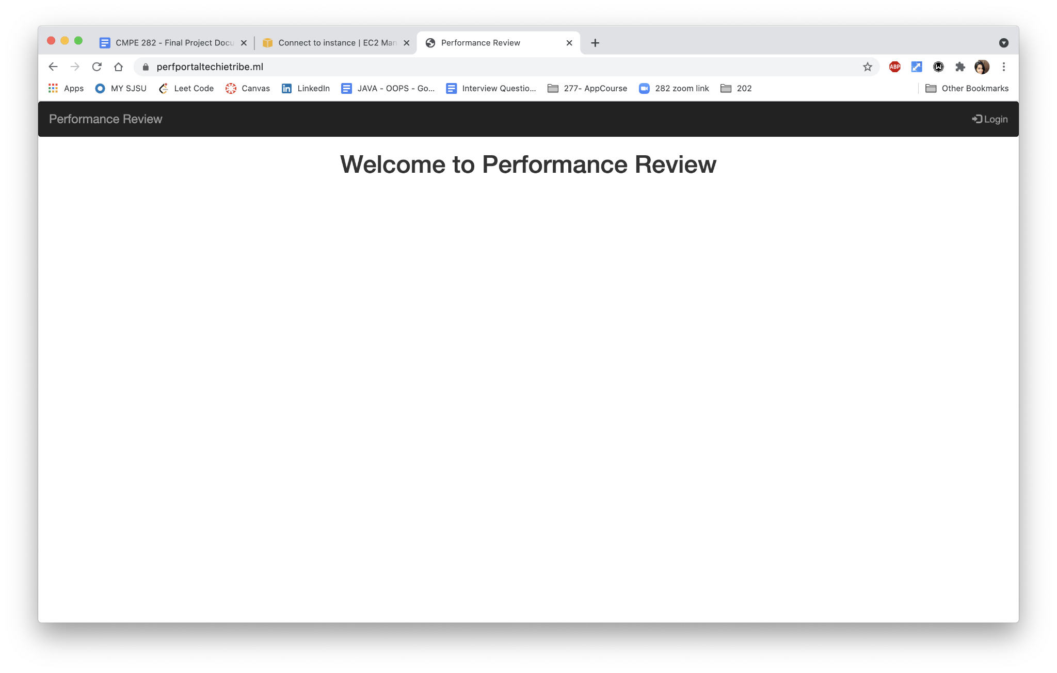

Login as Manager using Okta

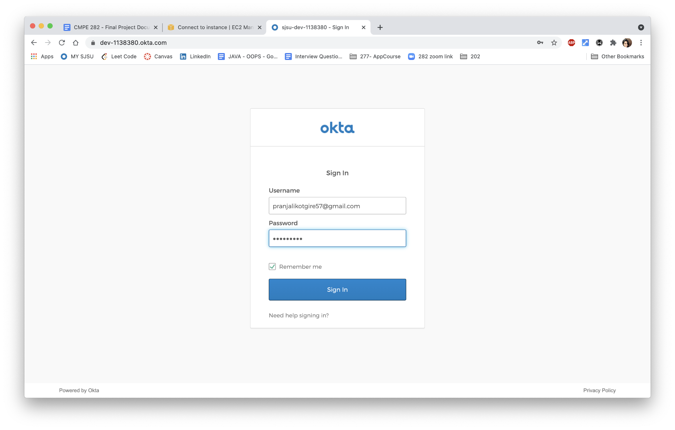

Manager Dashboard with chatbot

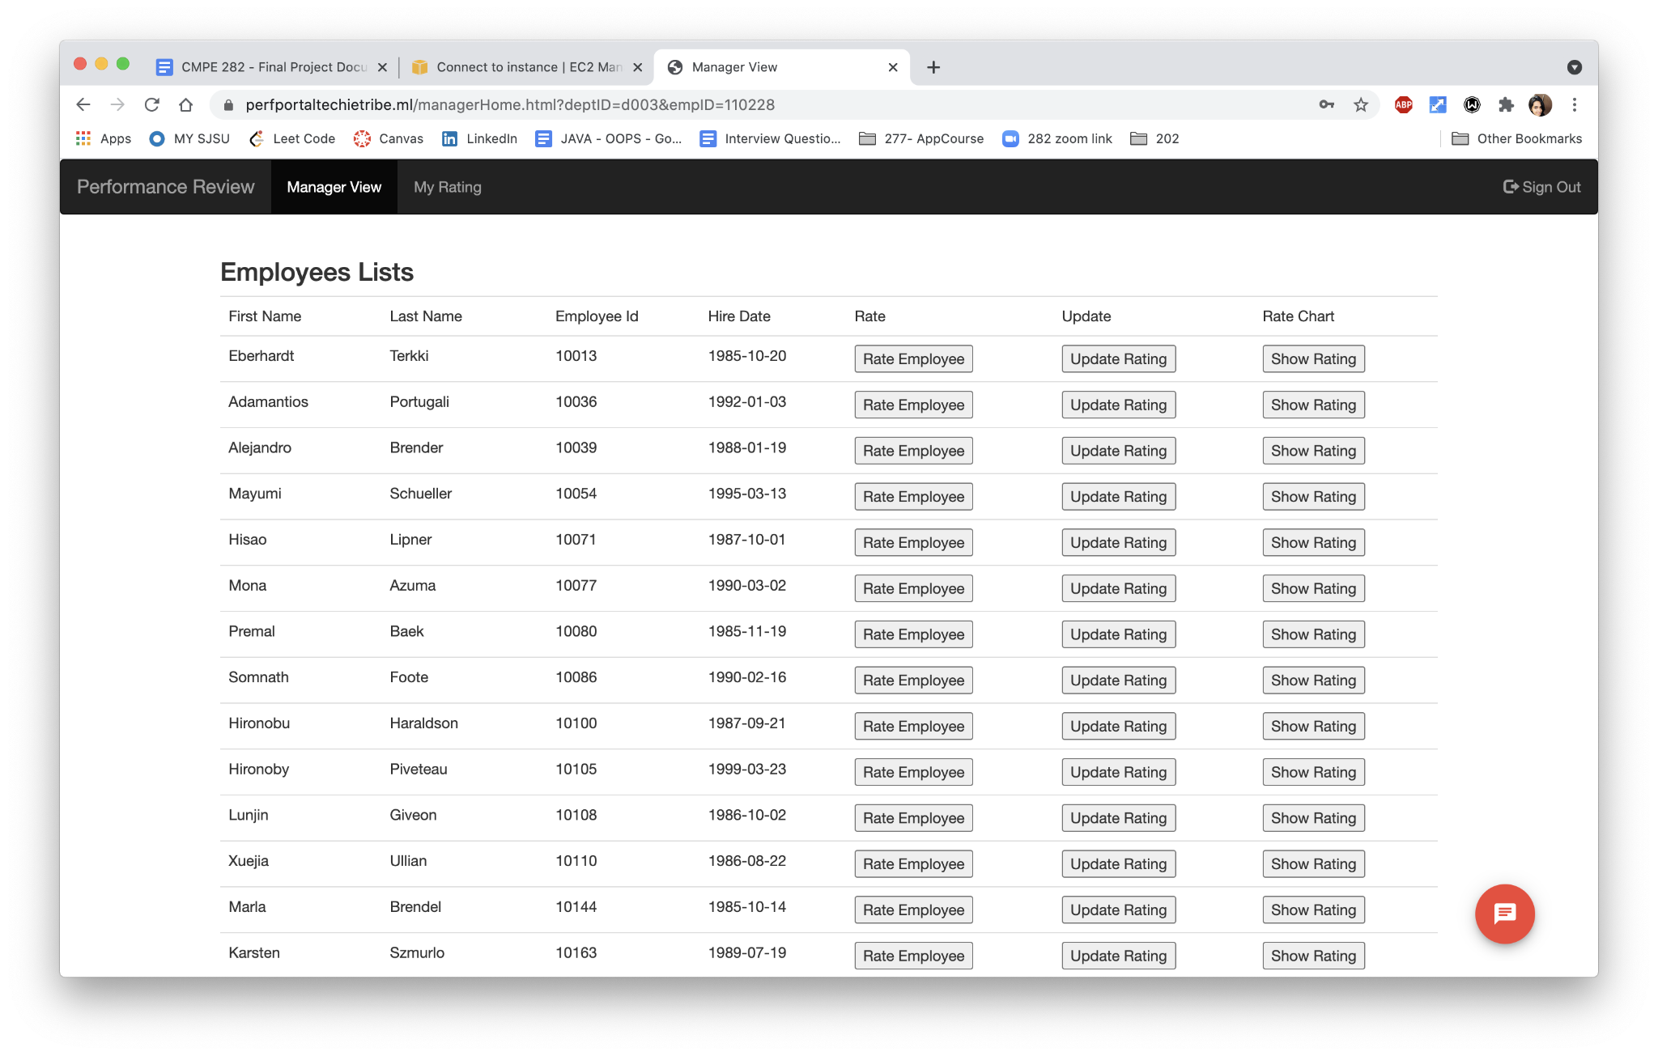

Chatbot view: we named our chatbot as “**Perfster”**

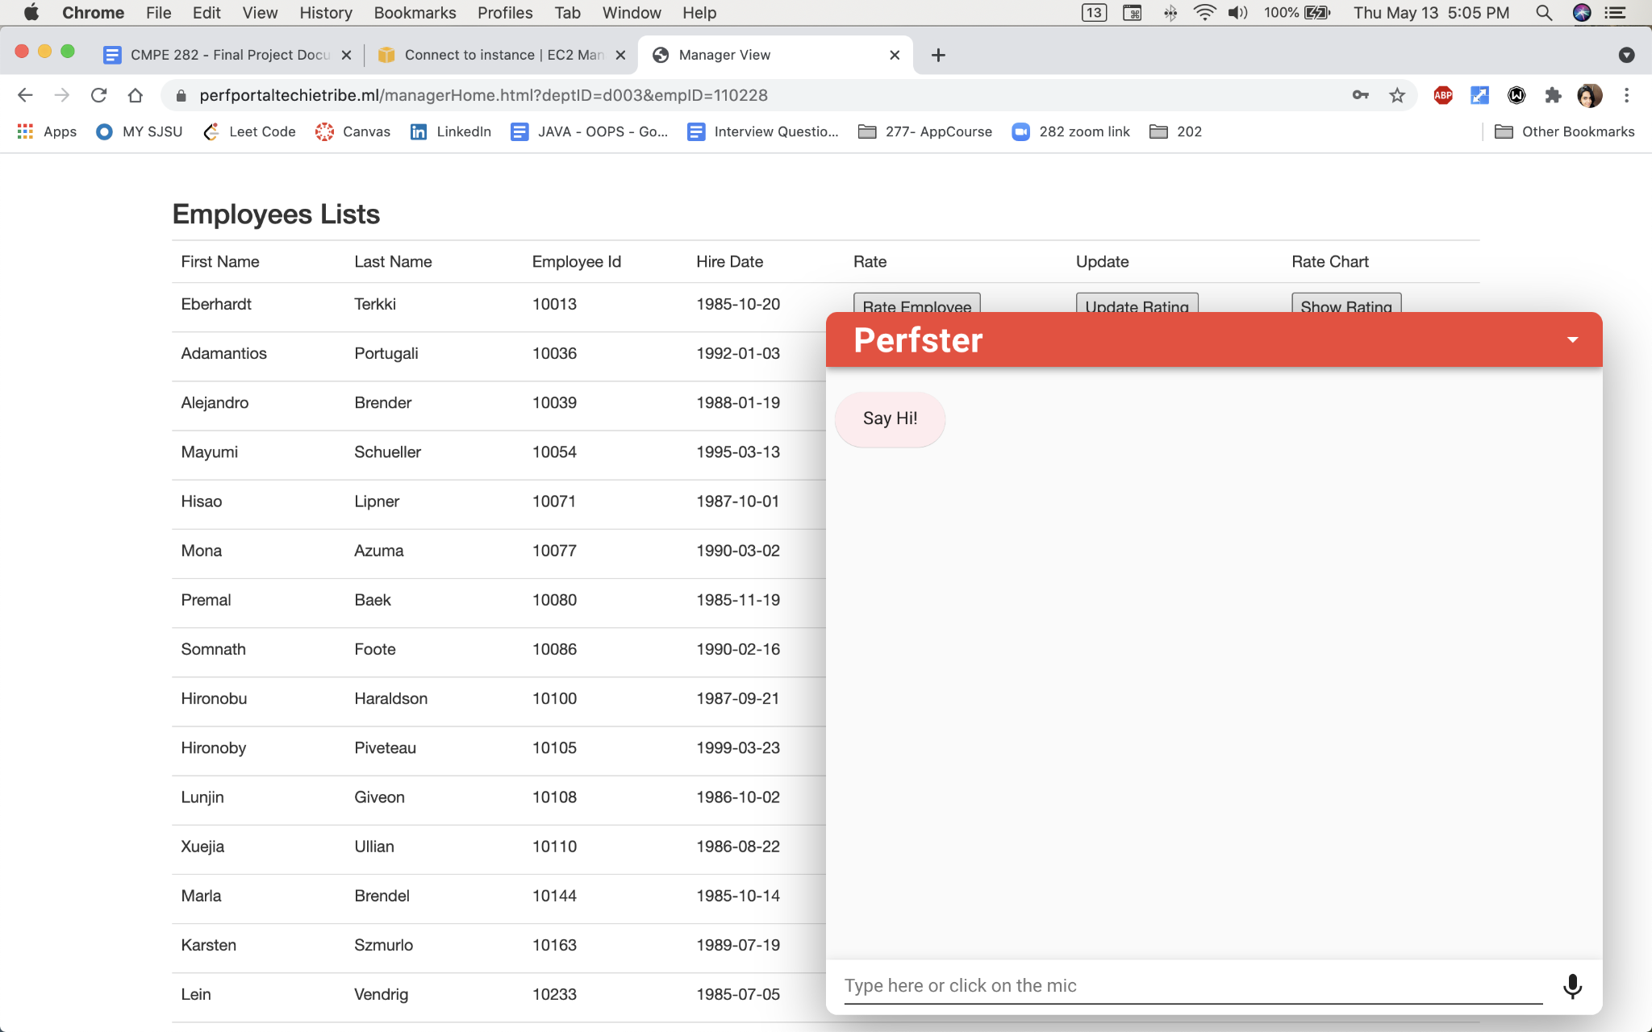

When Manager enters Hi, Perfster prompts the manager two options : Add Feedback/Update Feedback 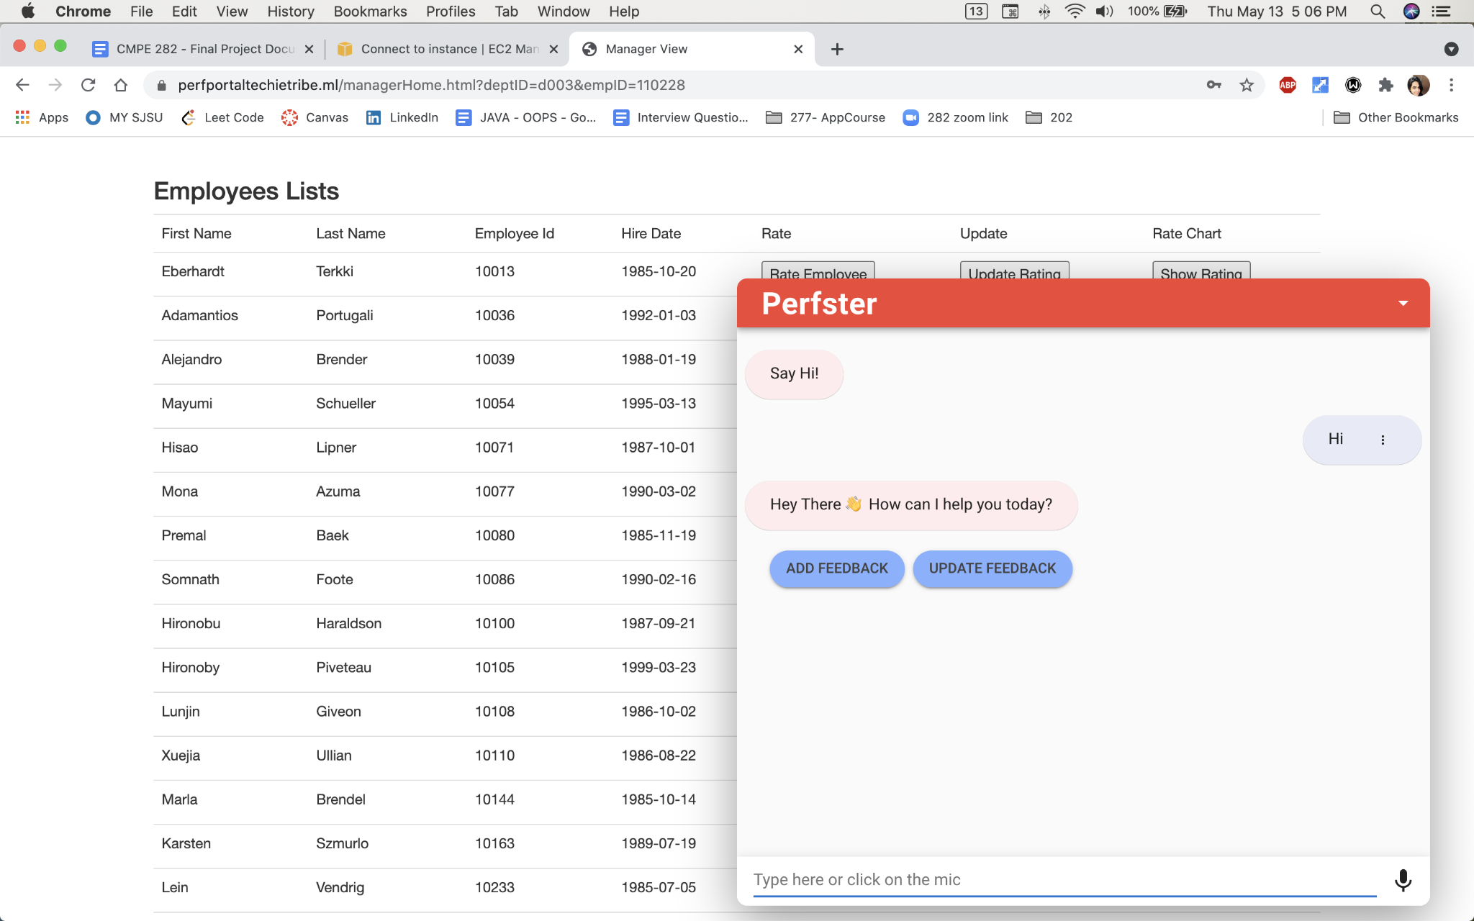

When Manager choses “Add Feedback” option, he/she should enter the employee for which we wants to provide feedback

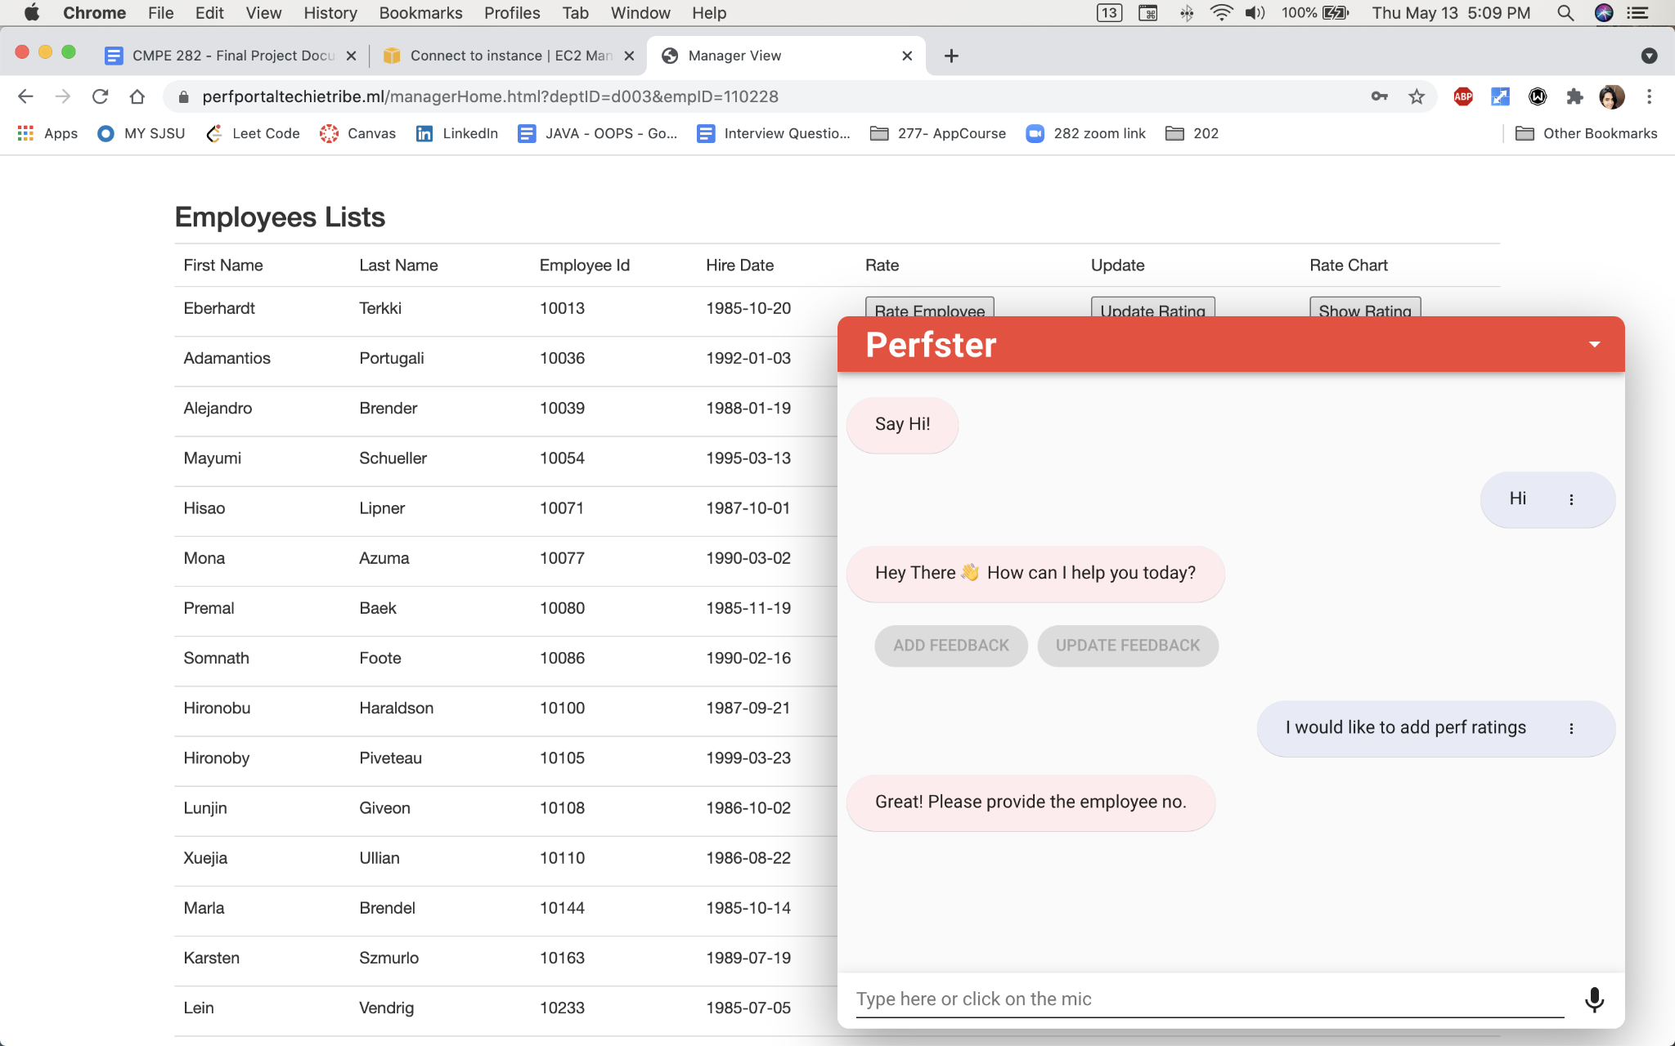

When manager enters the employee no, say 1077, if the employee already has feedback provided, then perfster fetches all the previous feedback and asks if manager would want to update it

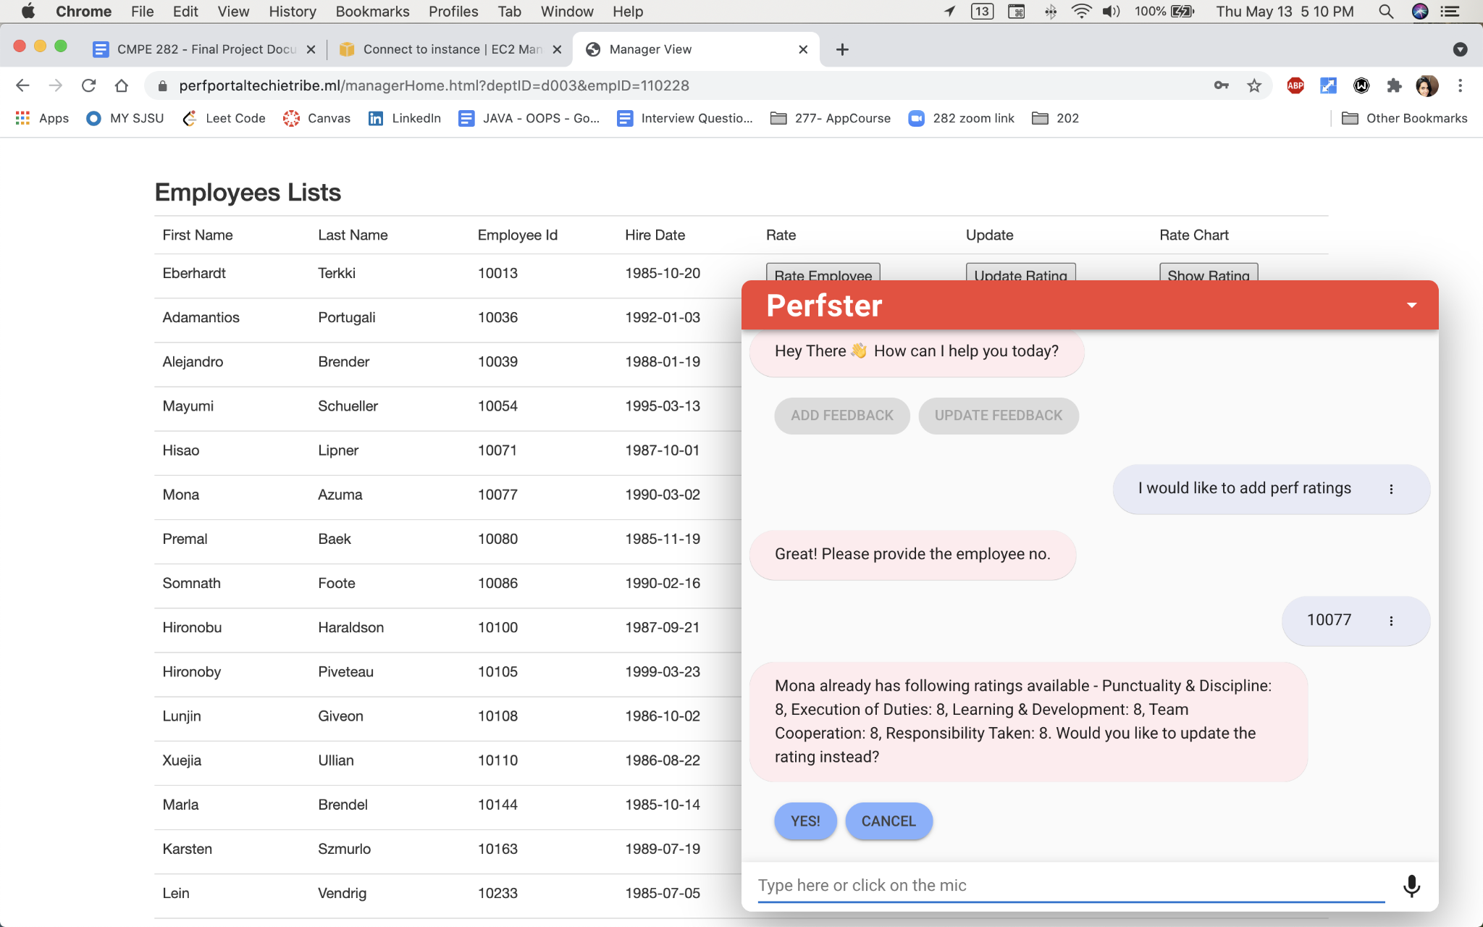

If manager choses “yes” , then perfster would continue asking few questions regarding the employee and saves employees feedback

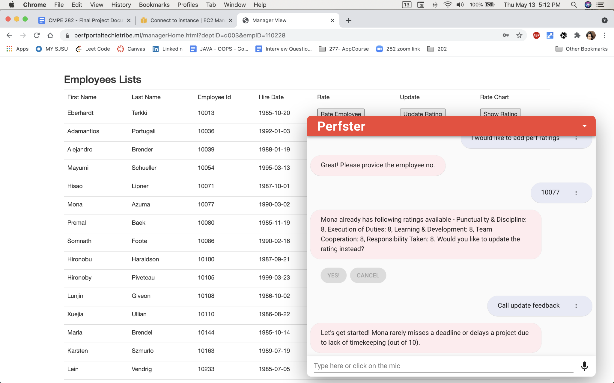

Below screenshots shows the set of questions asked by Perfster, once manager provides requested inputs, the changes can be either saved or cancelled based on manager’s input

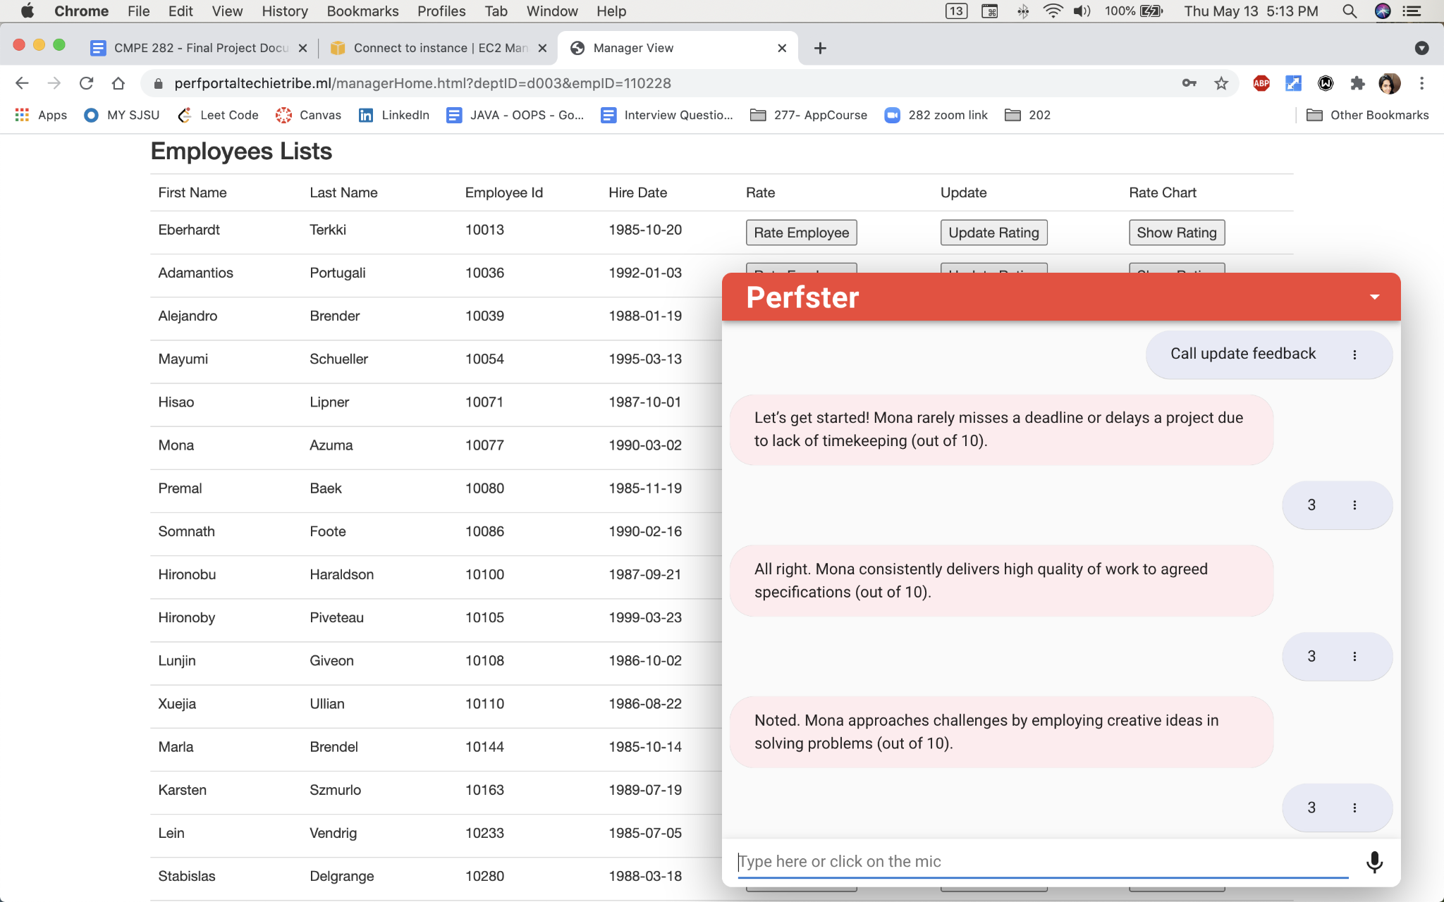

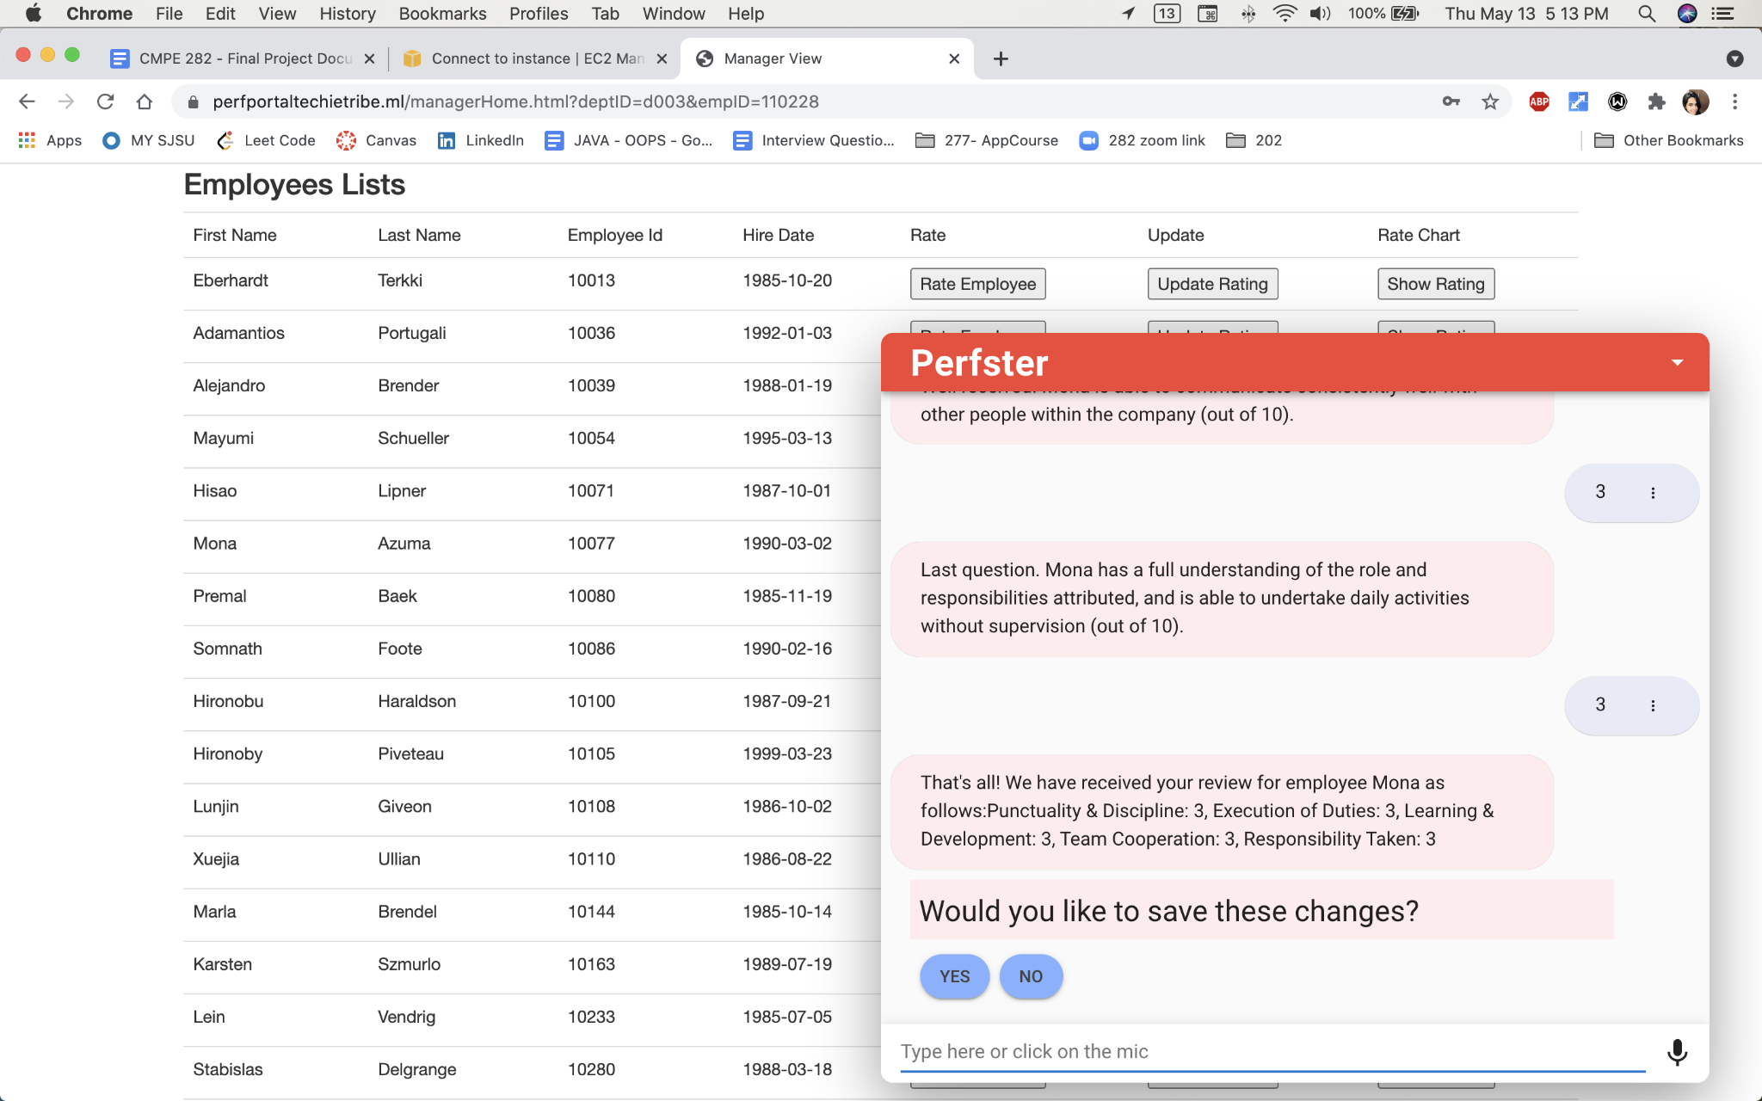

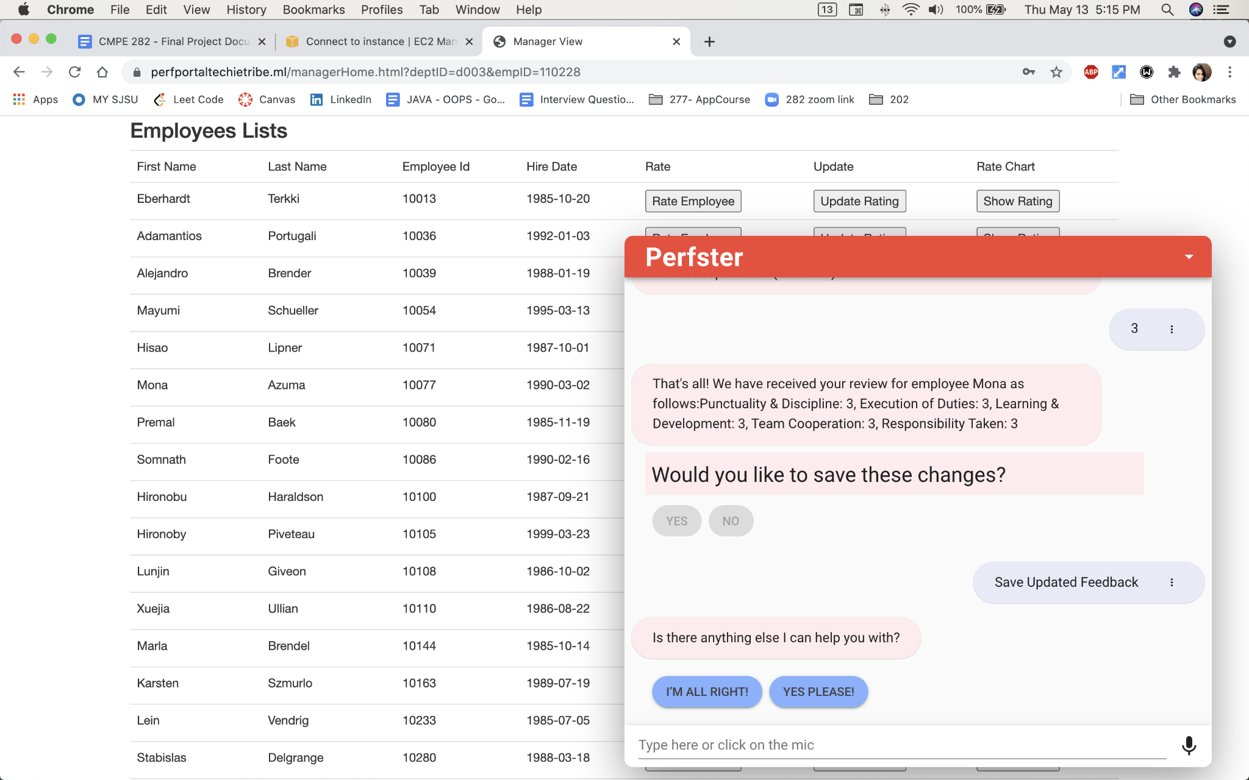

Logged in to the application as employee Mona Azuma(10077) - Employee id can be verified in the address bar.(login creds : sneha.magdum11@gmail.com/Apple@123

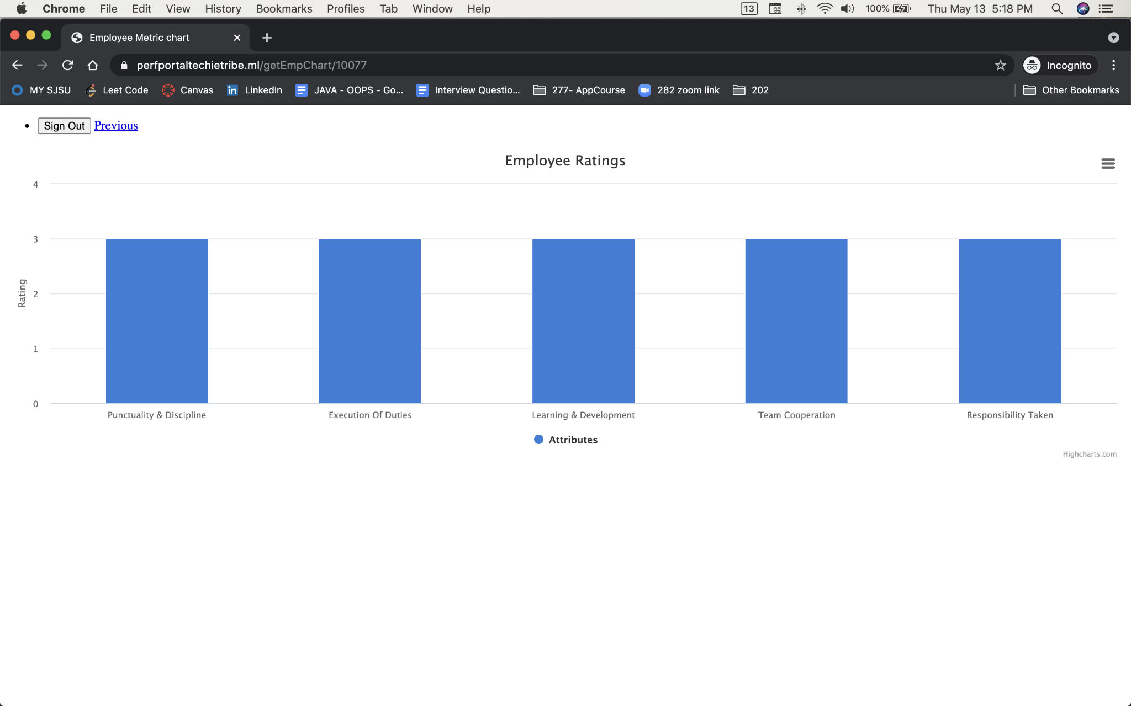

Also managers can provide feedback for the first time as well.

Employee No 10086 , login creds : pranjali.kotgire@[sjsu.edu/Apple@123](http://sjsu.edu/Apple@123) doesnt have any feedback given by manager.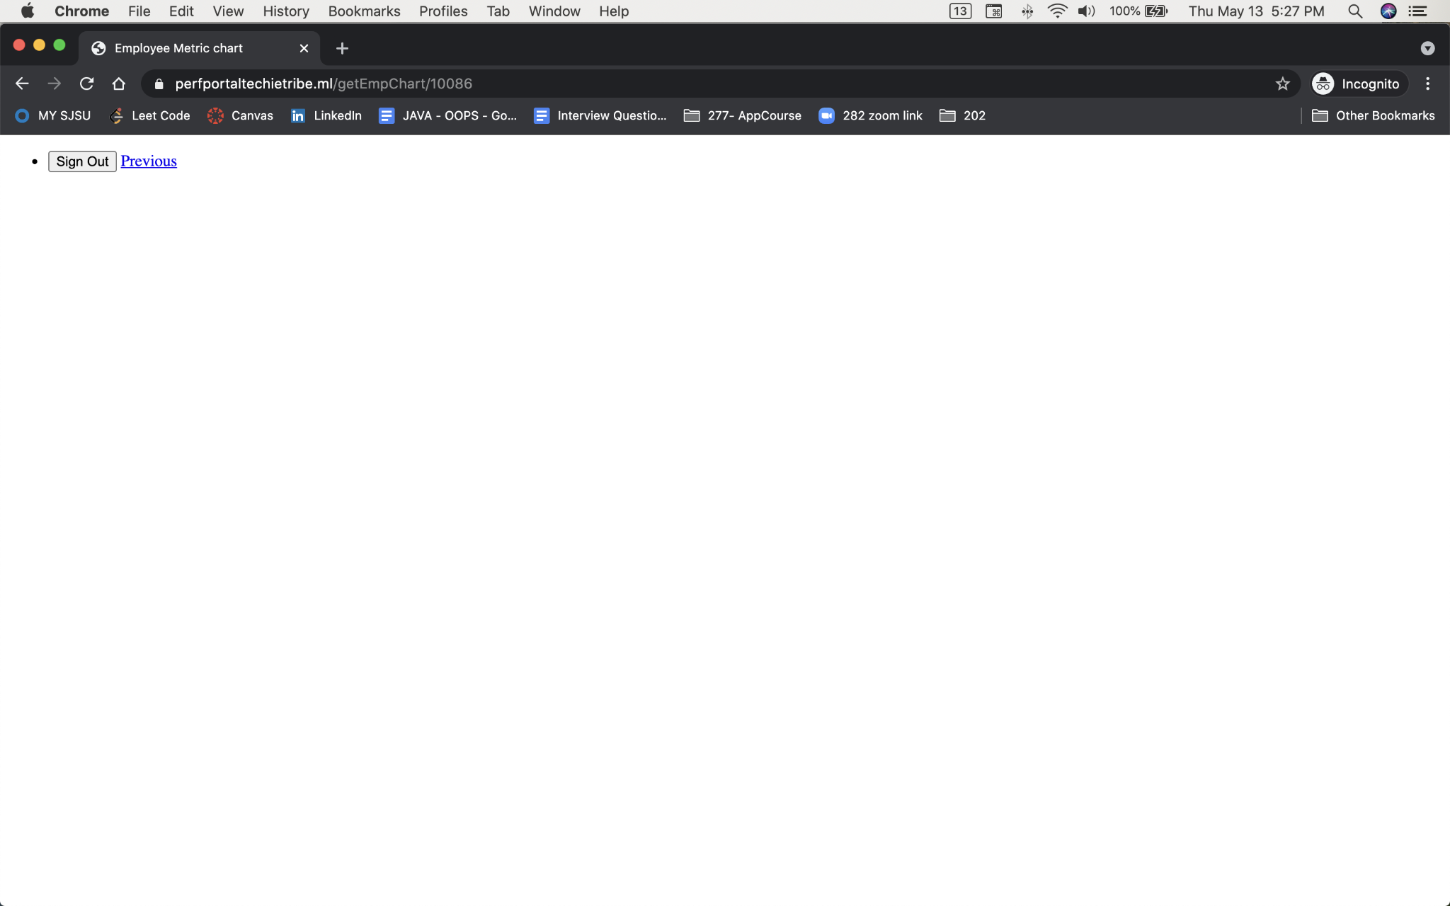

Now manager can provide his feedback for employee 10086 ,as shown below

